

**Applied Physics for**

**Scientists and**

**Engineers**

**To Determine Resistance of Galvanometer**

**by Kelvin ’s Method**

**Submitted to**

Sir. Haseen Ullah Jan

**Submitted by**

Muhammad Sadeeq Computer Systems Engineering

Sec C ETEA ID. 75025



**Introduction:**

The Kelvin double bridge is the modiﬁ cation of the Wheatstone bridge and

provides greatly increased accuracy in measurement of low value resistance. An understanding of the Kelvin bridge arrangement may be obtained by the study of the difﬁculties that arise in a Wheatstone bridge on account of the resistance of the leadsand the contact resistances while measuring low valued resistance.The Kelvin double bridge incorporates the idea of a second set of ratio arms-hence the name double bridge-and the use of four terminal resistors for the low resistance arms



**Principle:**

The principle of wheatstone bridge is used in order to measure the

unknown resistance i.e. in this case, of galvanometer while knowing the other three resistances.

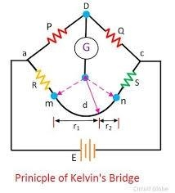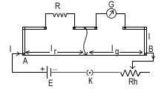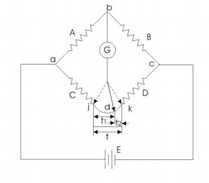

**Materials Needed:**

Following apparatus is used to carry out this demonstration: 1. Battery

1. High Resistance Box
2. Post Of ﬁce Box
3. Connecting Wires
4. Galvanometer



**DIAGRAM:**



**PROCEDURE:**

1 . Experiment is setup by making appropriate connections according

to diagram.

2 . Firstly apply the resistance in H.R.B. to set the galvanometer in

range. Applying resistance in P and Q and then applying resistance resistance R to check if the instrument is working properly.

1. Secondly, apply resistance P=10, Q=10 andR=140, press K1 and then k2 to check the de ﬂection.
2. At speci ﬁc resistance R=140, meter showed no de ﬂection,

hence Galvanometer is balanced. 6. Repeat the same process for P=1000, Q=100, R=1400 we get X=Rg=140 and so on.

**CALCULATIONS AND OBSERVATIONS:**

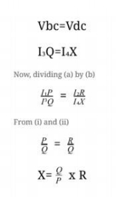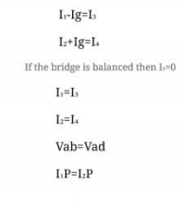

**Data:**

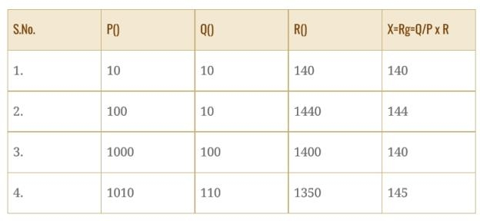

**RESULT:**

Mean Value i.e resistance of the galvanometer= 142.25

**PRECAUTIONS:**

1. Make appropriate connections.
2. Clean the wire ends.
3. Fix the knobs tightly.Repeat experiment and take mean values. 4. DO NOT ATTACH GALVANOMETER IN PARALLEL WITH ANY

E.M.F SOURCE.